DEPARTMENT OF APEX INSTITUTE OF TECHNOLOGY

# PROJECT PROPOSAL

# Project Title: - Arduino-Based Home Automation System Using Bluetooth.

* **Project Aim:** - This project is one of the important Arduino. Arduino-based home automation using Bluetooth project helps the user to control any electronic device using the Device Control app on their Android Smartphone. The Android app sends commands to the controller – Arduino, through wireless communication, namely, Bluetooth. The Arduino is connected to the main PCB which has five relays as shown in the block diagram. These relays can be connected to different electronic devices. As per the block diagram, Device 1 – Buzzer, Device 2- Fan, Device 3 – Lights.
* When the user presses the ‘On’ button displayed on the app for device 1, the Buzzer is switched on. This Buzzer can be switched off, by pressing the same button again.
* Similarly, when the user presses the ‘On’ button displayed on the app for device 2, the fan is switched on. The fan can be switched off, by pressing the same button again.
* This project of home automation using Bluetooth and Arduino can be used for controlling any AC or DC devices. In the demonstration, we used a DC Fan and a DC Bulb. To drive this DC Fan and Light, a 9V battery is connected.
* **Parts of the project:** - Device 1 – Buzzer, Device 2- Fan, Device 3 – Lights.
* 2. **Project Scope: - (Max 500 words)**

### **Applications of Arduino-Based Home Automation Using Bluetooth**

* Home automation using Bluetooth and Arduino can prove to be very useful for Elderly/Handicapped people
* A single Android smartphone can control multiple devices
* Any Android phone can be used, no internet is required once the app is downloaded.

### **(b) Future development**

* Arduino-based device control using Bluetooth on the Smartphone project can be enhanced to control the speed of the fan or volume of the buzzer etc.
* Home automation and Device controlling can be done using Internet of Things – IoT technology.
* We can replace Bluetooth with a GSM modem so that we can achieve [device control by sending SMS using a GSM modem](https://www.projectsof8051.com/sms-based-device-control-using-gsm-modem/).

1. **Advantages of Arduino-Based Home Automation Using Bluetooth**

* Can control the device from a long distance, thus it gives ease of access.
* Faster operation and efficiency.
* No need to carry a separate remote or any other controlling unit.
* Eliminates continuous monitoring, it facilitates 24 24-hour a day, 365 days in year communication between system and user.
* Commands can be given through remote places, directly to the machine.
* By further modification security system can be added.
* Easy to install & simple to operation.
* Low cost, high reliability & flexibility.

### **Requirements: - Technical Specifications for this project:**

1) A smartphone or an Android mobile that should have the Android app installed in it.

2) Bluetooth receiver module – Our project will be connected to the smartphone using Bluetooth technology.

3) Controller or the main processing circuit- In this project, Arduino Uno is the main controlling/processing unit. Also, this project can be developed using PIC18F4550, AVR ATmega32, and 8051 series like 89s51, 89c51, 89s52, 89v51RD2.

4) LCD Display – The Liquid Crystal Display is optional but shows important messages like device status once a command is received from Bluetooth.

5) Relays to control devices – We have used 12volt Single push single throw relays.

6) Output devices – For the demo purpose, we connected 2 DC devices to 2 relays (12-volt DC Fan and 12-volt DC bulb). You can connect any AC/DC devices to the remaining 3 relays. Also, Device 6 is a Buzzer.

**BLOCK DIAGRAM OF ARDUINO-BASED HOME AUTOMATION USING BLUETOOTH**

### Arduino based home automation using Bluetooth

**CIRCUIT DIAGRAM**

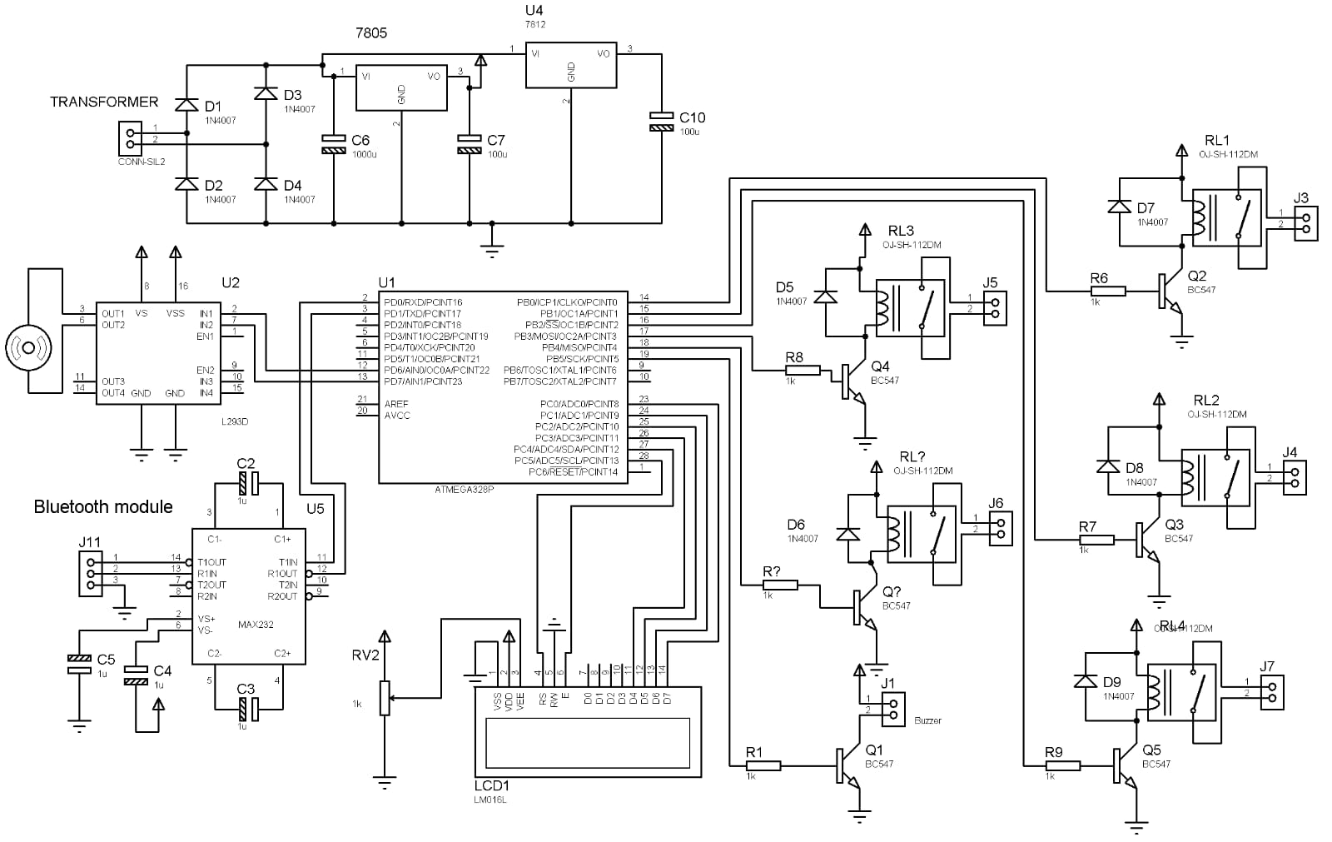

**STUDENTS DETAILS**

|  |  |  |
| --- | --- | --- |
| **Name** | **UID** | **Signature** |
| Amritpal Kaur Dhillon | 22BIS80001 | Amritpal Kaur Dhillon |
|  |  |  |
|  |  |  |
|  |  |  |
|  |  |  |
|  |  |  |

**APPROVAL AND AUTHORITY TO PROCEED**

We approve the project as described above, and authorize the team to proceed.

|  |  |  |
| --- | --- | --- |
| **Name** | **Title** | **Signature**  **(With Date)** |
|  |  |  |